Project Design Phase-II
Data Flow Diagram & User Stories
Date | 29 September 2026
Team ID | SWTID-2026-7644
Project Name | Script-Controlled ACL – Restrict Record Access Based on Field Value
Maximum Marks | 4 Marks
Data Flow Diagrams:
A Data Flow Diagram (DFD) is a traditional visual representation of the information flows within a system. A neat and clear DFD explains how data enters the system, how it is processed, and how the resulting access decision is produced.
Example: (Simplified)
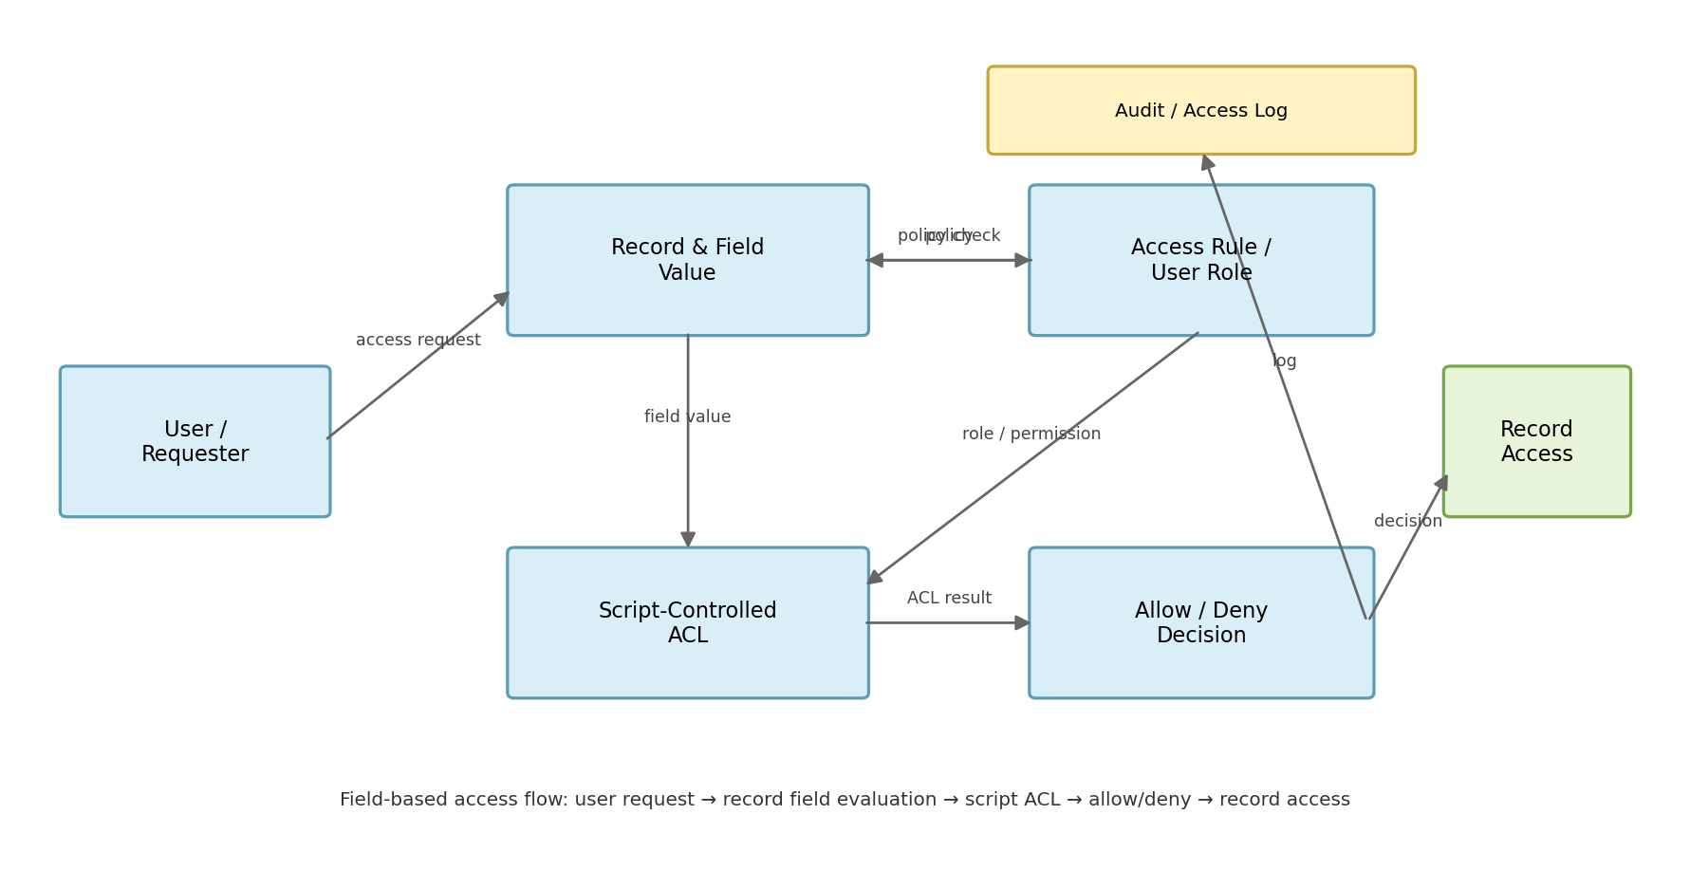
Flow
1. User requests access to a record through the application.
2. The system identifies the requested record and the field value used for access control.
3. The script-controlled ACL evaluates the user's role and the record's field value.
4. The ACL returns an Allow or Deny decision based on the configured rule.
5. The system displays the permitted record or blocks access and records the decision for auditing.

User Stories
Use the below template to list all the user stories for the product.
User Type | Functional Requirement  (Epic) | User Story  Number | User Story / Task | Acceptance criteria | Priority | Release
System Administrator | ACL Configuration | USN-1 | As an administrator, I can configure an ACL to restrict record access based on a selected field value. | I can save the ACL with the selected field and access condition. | High | Sprint-1
System Administrator | Script Logic | USN-2 | As an administrator, I can write or update the script that evaluates the record field value. | The script correctly evaluates the field value for test records. | High | Sprint-1
System Administrator | Role Mapping | USN-3 | As an administrator, I can define which users or roles are permitted to access specific field values. | Users receive access only when their role/value combination matches the rule. | High | Sprint-1
Business User | Record Access | USN-4 | As a user, I can open a record when its field value matches my permitted value. | The record is displayed without an access error. | High | Sprint-1
Business User | Record Restriction | USN-5 | As a user, I cannot open a record when its field value is outside my permitted value. | The system denies access and does not expose the restricted record. | High | Sprint-1

User Type | Functional Requirement  (Epic) | User Story  Number | User Story / Task | Acceptance criteria | Priority | Release
System Administrator | Testing | USN-6 | As an administrator, I can test both allowed and denied field-value scenarios before deployment. | Positive and negative test cases return the expected result. | Medium | Sprint-2
System Administrator | Audit / Logging | USN-7 | As an administrator, I can review access decisions for troubleshooting and auditing. | Allow/deny decisions contain enough information to identify the request and result. | Medium | Sprint-2
Application User | Clear Feedback | USN-8 | As a user, I receive a clear message when access is denied by the ACL. | The message explains that access is restricted without revealing protected data. | Medium | Sprint-2
System Administrator | Maintenance | USN-9 | As an administrator, I can update the field-based rule when business requirements change. | Updated rules apply consistently to new access requests. | Low | Sprint-2
Project Owner | Security Review | USN-10 | As a project owner, I can verify that record access follows the defined field-based security policy. | Review confirms authorized users can access permitted records and restricted users cannot. | Low | Sprint-2
User Story Completion Criteria
• Access rules must evaluate the configured field value at the time of the request.
• Authorized users should receive the requested record when the rule condition is satisfied.
• Unauthorized users should be blocked without exposing protected record information.
• Scripts and ACL conditions should be testable, maintainable and auditable.

